Statement by Each Algorithm Submitter
I, Kaiyi Zhang , Institute for Advanced Study, Tsinghua University. Beijing, China , to the best of my knowledge of my submitted algorithm Kylin and its implementations (reference and optimized implementations included), do hereby declare:
1. I commit that my submitted algorithm and its implementations are in compliance with the security requirements, including but not limited to the requirements that the algorithm does not contain any backdoor or defect artificially designed and its implementations do not contain any malicious code. I do hereby commit that to the best of my knowledge, my submitted algorithm and its implementations do not contain any data, information or technology that may infringe upon trade secrets, or may involve confidentiality required by the laws and regulations of China and other countries.
2. I acknowledge and agree that my submitted algorithm and its implementations will be provided to the public for evaluation, analysis and review. I agree that any interested party, including the program organizer, public reviewers, etc., can freely use the algorithm and its implementations for evaluation purpose. I acknowledge that the program organizer will select several algorithms as candidates for the next-round evaluation or the finalists after evaluation and analysis; my submitted algorithm might not be selected as a candidate for the next-round evaluation or the finalist. I acknowledge that I will not receive financial or other compensation from the program organizer for my submitted algorithm.
3. To facilitate the next-generation commercial cryptographic algorithm standardization, I acknowledge and agree that if my submitted algorithm is selected for the finalists, the program organizer may modify the algorithm and its implementations out of security, availability or other considerations. If my submitted algorithm is selected for the finalists and to be standardized, I commit to place no restriction on the worldwide disclosure and free adoption of algorithm and its implementations.
4. I commit that the algorithm and its implementations are my (or my team’s) own original work. The implementations of my submitted algorithm do/do not adopt code or code libraries requiring authorization by third parties. Except those clearly identified, citations and acknowledgment, all the opinions, words, diagrams and data in the submission are my own (or my team’s) original research results, and the submission does not contain any published work from other individual or team.
5. (Please check one of the following two options.)
I do not hold and do not intend to hold any patent or patent application which may cover my submitted algorithm and its implementations, and to the best of my knowledge, no patent or patent application may cover my submitted algorithm and its implementations.
The following patent(s) and patent application(s) may cover my submitted algorithm and its implementations. As for patent(s) and patent application(s) held by myself, I have submitted/have not submitted all statements; as for patent(s) and patent application(s) held by others, I have submitted/have not submitted all statements signed by patent and patent application owner(s).
Table The List of Patent(s) and Patent Application(s)
No. | Patent/Patent  Application No. | Title of Patent/Patent  Application | Patent/Patent  Application Owner(s) | Whether submit statements  signed by each owner
 |  |  |  | Yes No
 |  |  |  | Yes No

I do hereby declare that to the best of my knowledge, I have fully disclosed all patents and patent applications which may cover my submitted algorithm and its implementations. I commit that to the best of my knowledge, my submitted algorithm and its implementations are in compliance with the laws and regulations of China and other countries, and do not infringe upon legitimate rights and interests of any third party. Where there is a dispute concerning patent infringement or violation of laws and regulations, I commit that the algorithm submitter(s) shall take the responsibility of dealing with it and eliminating negative effects as well as bearing corresponding legal liabilities.
I am fully aware that I bear the legal consequences of this statement.

Signed: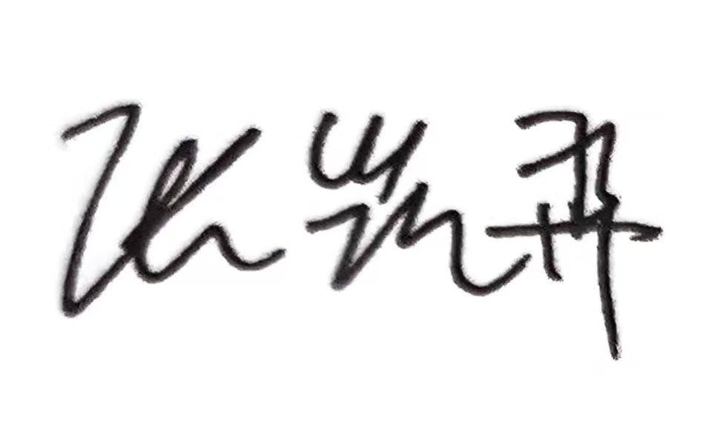
Date: 2026/04/27

